**Compressed Gas Cylinders**

**Types of Hazards associated with Compressed Gas Cylinders**

1. Physical Damage: Cylinders are very dangerous when damaged. Damage can be caused by falling over, tipping, heat, electric circuits, motion, vibration or anything that may cause weakness or crack to the cylinder walls. A result my cause a cylinder to rupture or explode.
2. Tipping and Falling: This is one of the most common hazards with cylinders. Make sure to handle cylinder with special care and with the proper equipment and PPE.
3. Valve leakage: Store cylinders in well ventilated areas and be sure that proper storage guidelines are followed.

**Proper Storage and handling of Compressed Gas Cylinders**

* Store cylinders in an upright position and secure with chain, strap, or cable to a stationary building support or to a cylinder cart. Below are examples:

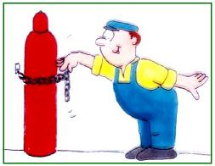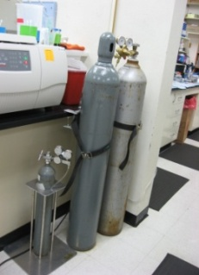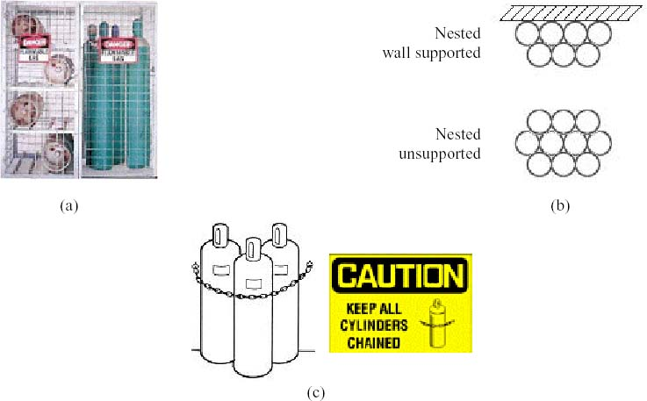

* Segregate empty cylinders from full cylinders. Label empty to cylinders to avoid any confusion.
* Cylinders should be stored in a well ventilated area.
* 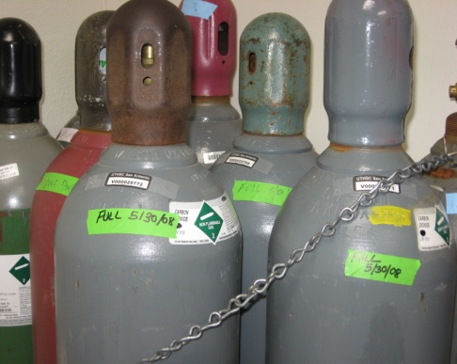When cylinders are not being used, make sure valves are closed and valve caps are secured in place. This true while stored in the lab or the compressed gas storage room.
* Be sure to cylinders are segregated properly
  + Non Flammable Compressed Cylinders Room0026
  + Flammable Compressed Cylinders Room 0028
  + Keep oxygen cylinders 20 Feet away from fuel cylinders with a non combustible barrier.
* All cylinders whether full or empty must comply with NFPA and DOT labeling requirements and OSHA hazard communication requirements.
* Cylinders must not be stored in exit or egress paths.
* 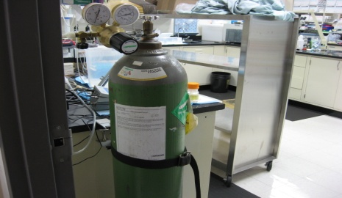Make sure the proper regulator is being used for the type of gas in the cylinder.
* Attach regulators securely before opening the valve.
* When opening cylinders valves make sure you stand to side and open slowly.
* Do not carry or lift a cylinder by its valve or cap.

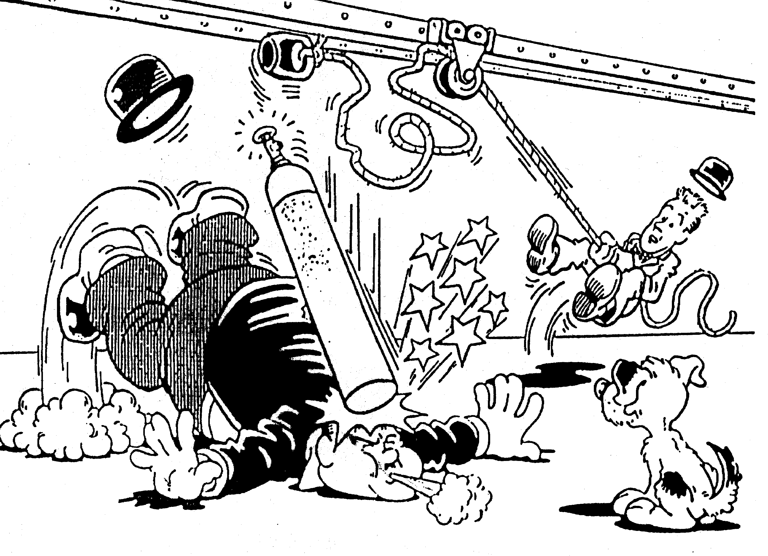

* Do not leave a cylinder unsecured.

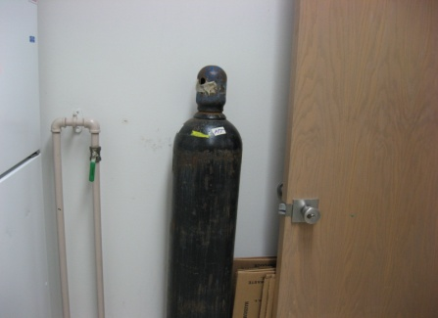

**Improper Storage of Cylinders found at ISC**

1. 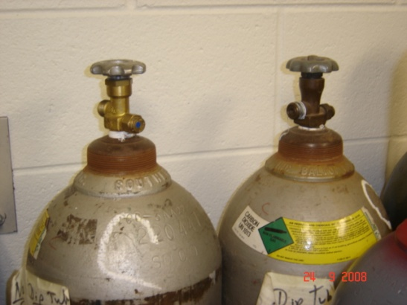**Improper storage of without Caps.** While cylinders are stored in the cylinder storage room, they must have valve caps and be nested and secured by chains. The cylinders in the picture are chained properly but are missing caps. Caps are used for valve protection and should be kept on the cylinders at all times, except when the cylinder is actually being used or charged. Cylinder valves should remain closed. Furthermore, Cylinders must be transported by hand carts designed to hold cylinders. Cylinders must be chained to the cart to prevent them from falling or striking each other. Do not move cylinders with regulators attached. Lastly, never move a cylinder without its valve cover firmly attached. In addition, these cylinders cannot be shipped by the vendor until these caps are replaced per requirement of the Department of Transportation (49 CFR 173.301).
2. 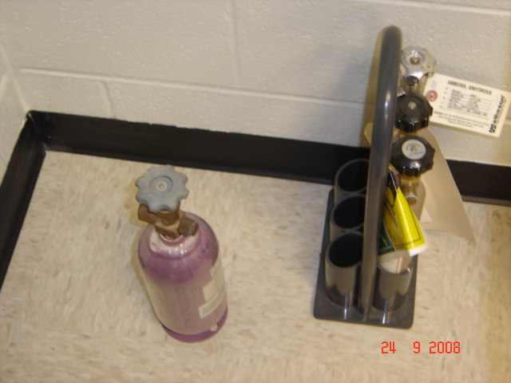**Cylinder Not Secured Properly.** All Cylinders must be secured properly while in storage. I have put a plastic crate in there to store this small lecture cylinder of Ammonia. Please make sure you keep in mind segratation before putting other lecture cylinders in this crate. If you need more plastic cylinder crates please let me know.

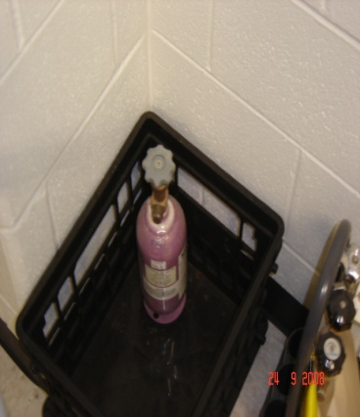

**Improper Storage** **Proper Storage**

**References:**

Cornell University: http://www.med.cornell.edu/ehs/updates/compressed_gases.htm